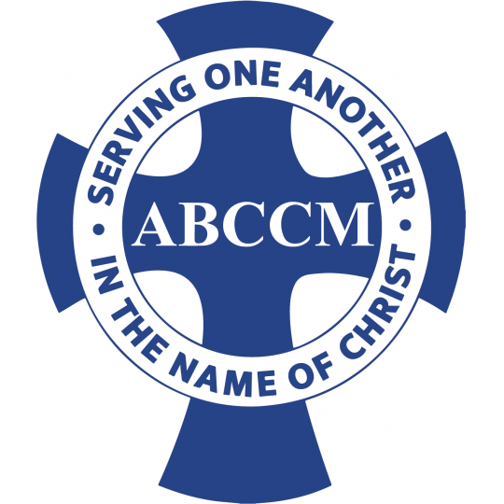

Chief Development Officer
Position Announcement
March 28, 2025

Position Profile: Chief Development Officer
Hiring Range: $100,000 - $115,000
Applications will be accepted until: May 31, 2025

Asheville Buncombe Community Christian Ministry
1845 Brevard Road
Arden, NC 28704

The Opportunity

Asheville Buncombe Community Christian Ministry (ABCCM), a leading faith-based nonprofit organization addressing poverty, hunger, homelessness, and access to healthcare for underserved populations across North Carolina, is seeking an experienced development professional with a strong track record of success across all areas of fundraising to lead our development efforts. This member of the Senior Leadership Team will report to the Executive Director and supervise the Marketing Director, Special Events Coordinator, Grant Writer, Donor Relations Coordinator(s) and specialized teams of volunteers/committees.

The Chief Development Officer will lead all aspects of a complex, established fundraising effort by strategically engaging Board members, senior leadership, while interacting with supporters and partners. ABCCM has an intentional relationship approach to generate both financial and in-kind support for ABCCM Ministries and services.

ABCCM’s core values are expressed in its Mission as a Christian Ministry organized to provide individuals the opportunity to grow, mature and express their faith through fellowship and service. These services engage churches, volunteers and community leaders to offer short-term and long-term solutions to families in crisis.

ABCCM

ABCCM is a family of 300 Christian congregations organized to maximize impact by doing together what individual congregations cannot do separately, in a true ecumenical spirit. The organization is committed to Christ, and to translating faith into cooperative action which ministers to the spiritual, social, physical, economic and emotional needs of our neighbors across North Carolina. Through Christ, we persevere to restore and/or maintain the dignity of every person, bring reconciliation to hostilities, provide new skills, strategies, and hope to the thwarted/disadvantaged lives, and share our common victories of life.

ABCCM creates opportunities for churches and volunteers to serve through seven distinct ministries: Crisis Ministry, Jail Ministry, Medical Ministry, Veterans Services of the Carolinas, and two emergency shelter, transitional and permanent supportive housing campuses: Transformation Village, Veterans Restoration Quarters, plus a Recovery Living Center (addictions treatment) at Costello House. These Ministries are supported by a strong, dedicated core of 7,400 volunteers, over 300 church partners, 300+ staff members, which last year provided a $47.6 million community impact ($30.2M in cash-$17.4 in-kind).

ABCCM is seeking highly qualified candidates who are passionate about our mission. We are looking for individuals with a strong Christian faith, who are both strategic thinkers and results-oriented leaders—driven to succeed, assuring, and engaging with people from all walks of life. As we launch a major capital campaign, the Chief Development Officer will be expected to play a collaborative leadership role with the CEO while leading an effective team in ABCCM’s successful annual fundraising strategies.

ABCCM is preparing to launch a $40+ million capital campaign to enhance and expand critical services for Veterans, their families, plus single women and mothers with children. This campaign will support the restoration of the Veterans Restoration Quarters—a 250-bed transitional housing facility severely damaged by Hurricane Helene—expanding the campus at Transformation Village with the development of 64 units of transitional and 150 apartment units of permanent supportive housing facility for women and mothers with children, and the investment in a state-of-the-art Coordination and Call Center serving Veterans and Military families. The campaign will follow a phased, strategic approach with defined timelines and measurable goals, being developed collaboratively by the Senior Leadership Team, including this position.

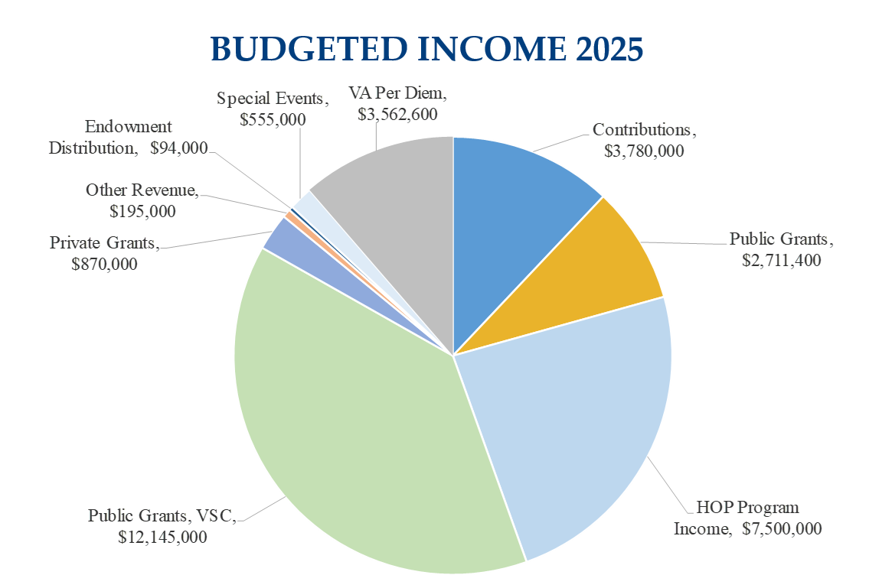

The Location


Nestled in the scenic Blue Ridge Mountains, Asheville, North Carolina, is a vibrant and growing city known for its thriving arts scene, rich cultural heritage, outdoor recreation, and strong sense of community. Asheville is served by two primary public-school districts: Asheville City Schools and Buncombe County Schools. According to Niche's 2025 rankings, Asheville City Schools is rated 10th out of 115 school districts in North Carolina. According to the U.S. Census Bureau's 2023 American Community Survey, the median household income in Asheville was $66,032, while the median home sale price is $500,000 (Zillow) highlighting the dynamic nature of the region’s real estate market. ABCCM manages eight office locations in Buncombe County while also maintaining offices in Charlotte, Fayetteville, and Jacksonville.

Position Overview

The Chief Development Officer is an essential member of our team, as we serve those in need, and support an incredible team of Ministry Directors who have strategic plans to expand and enhance our services. We are seeking a senior-level development professional with a strong track record of year over year success in annual, major gift, event-based and grant fundraising. We seek a leader who can develop strategies supported by effective marketing that builds on vast network of existing relationships and collect new friends. We expect a leader who can layout specific strategies that will steward volunteers, prospects, donors and partners.

We are interested in candidates who can work effectively with Senior Leadership including our Church Engagement Officer in a servant-leadership model, that undergirds and provides resources for Ministry Directors to care for our neighbors in crisis with short-term and long-term strategies that will build intentional community at every level of the organization.

The Chief Development Officer must be self-motivated, and comfortable working independently, while also leading and managing project teams according to agreed upon timelines, outcomes and goals.

Primary Duties and Responsibilities

Fundraising Strategy and Implementation
- Engages with the Executive Director and Senior Leadership Team to increase support and participation in the mission of ABCCM through five major areas: individual and major gifts, special events, marketing, grant development and campaign leadership.
- Cultivate and shepherd an ABCCM Development Committee to train and engage church and community leaders in cultivating annual gifts, major gifts and capital campaign strategy.
- Manage, implement, and supervise annual fundraising campaigns focused on achieving goals by cultivating major donors through in-person meetings that build-grow relationships, confirm-affirm gifts and steward thank yous.
- Manage and collaborate with an events team responsible for four major fund-raising events and four friend-raising events by ensuring that strategic implementation is in place, financial goals are established, sponsorships committed, committees supported, logistics covered, and timely follow-up reports are shared. These events generate over $800k annually, from our annual Safe and Warm Campaign, Golf Benefit, Gala, Return to Bethlehem and Christmas Angel with greater potential accessible.
- Routinely collaborate with Executive Director, Chief Financial Officer, and Chief Operating Officer that follows a grant development and proposal process in an intentional team environment; with the seven Ministry Directors. Cultivates Grantor relationships to ensure success.
- Work to maintain strong community relationships with foundations, community leaders, businesses, ABCCM leaders, to add additional resources by strategically attending meetings, maintaining phone and/or email contact, and volunteer involvement.
- Steward planned giving messaging with the Marketing Director and utilizing ABCCM partners who can advise on their financial or estate plans.

Capital Campaign
- Provide primary leadership in the Capital Campaign structure, Campaign Committees, Captains, and volunteers to ensure consistent implementation, follow-up and momentum.
- Coordinate campaign efforts with outside consultants to ensure alignment and congruence with Capital Campaign team, tactics and plan.
- Engage with campaign volunteers as they network in the community, establishing new relationships and deepen existing ones, building the campaign donor commitments that achieves giving goals, at all levels.
- Lead a team in coordinating, managing and organizing campaign-related fundraising events, representing ABCCM at those events, and sharing inspirational stories, outcomes, campaign progress and celebrate achievements.
- Maintain a system within ABCCM’s database, working collaboratively with the CFO to track all campaign pledges, gifts, and follow-up with monthly reporting that tracks progress and ties to CFO monthly financials.

Marketing and Community Engagement
- Oversee marketing campaigns in concert with the Marketing Director and team. Supervise the implementation of the marketing strategic plan. Convene and engage with ABCCM Marketing Committee and staff marketing team in six channels of communication – social media, print, website, video, direct mail and digital.
- Participate in and represent ABCCM at community functions and church meetings to expand relationships in our networks and educate about ABCCM’s mission and services. This will include attending town halls, church functions, civic organization meetings such as Kiwanis, and Rotary Clubs, neighborhood meetings, and others as needed.

Administrative and Tracking Progress
- Maintain strong systems of accountability and reporting that utilize ABCCM’s existing data tools and monthly reporting schedule.
- Work closely with Ministry leaders to support strategic plans through grant development and donor development to increase funding.
- Maintain consistent and collaborative donor recognition for grant awards and/or individual donations through media releases, social media, naming opportunities or quarterly ABCCM General Assembly meetings.
- Maintain reports and structure which ties into the strategic plan, provide after action reports, and after-action reporting that evaluates the success of all development and marketing efforts.
- Provide a regular monthly dashboard to the Board of Directors that benchmarks development activity with financial giving, marketing activities, special events, and community engagement.
- Perform other duties as assigned.

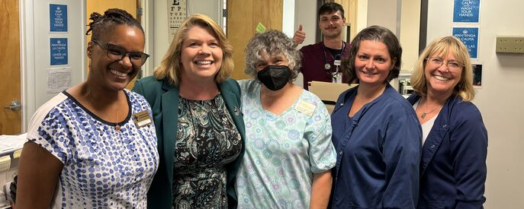

Desired Attributes and Qualifications

ABCCM is seeking a mission-driven, seasoned development professional who brings both heart and expertise to their work. The ideal candidate will be energized by the opportunity to build on ABCCM’s strong foundation of donors and volunteers that will lead the development team into a new era of philanthropic growth. This candidate will join and effective team with recognized mission and thought leaders that are deepening our impact across North Carolina. The successful candidate will demonstrate the following attributes and qualifications:

- Strong Christian faith and commitment to ABCCM’s mission, with a desire to serve others through a ministry that integrates spiritual care with equipping and empowering others to care for their neighbors and resolve crises through an intentional missional community model.
- Minimum of 7–10 years of progressive fundraising experience in a nonprofit setting, preferably in a faith-based or human services organization.
- Post graduate degree and CRFE certification preferred.
- Proven success in capital campaigns, major gifts, annual fund development, grant acquisition, event-based fundraising, and planned giving.
- Strategic thinker with a results-oriented mindset, capable of translating mission + vision into actionable plans with measurable outcomes.
- Excellent interpersonal skills, including a natural ability to connect with people from diverse backgrounds and all walks of life while offering them a relationship with ABCCM.
- Experience in supervising, leading, and mentoring development and marketing teams, through a collaborative and participatory management philosophy and meaningful accountability.
- Skilled with computer applications utilizing Microsoft Office, Blackbaud donor database, and project management with Monday.com. Demonstrated ability to track and evaluate development efforts, maintain congruency with financial reports, grant management, and a monthly dashboard report to Senior Leadership and the Board.
- Highly self-motivated, able to manage multiple complex projects independently while staying aligned with mission, team goals and timelines.
- Strong experience in project management, including meeting timelines and achieving goals

Compensation and Benefits

The salary range is $100k - $115k commensurate with experience and qualifications. In addition to a salary aligned with industry standards for similar nonprofit leadership roles, we provide a comprehensive benefits package that includes health, dental, and vision insurance, paid vacation and holidays, retirement plan options with employer contributions, and professional development opportunities. As a faith-based organization, ABCCM also fosters a supportive and mission-driven work environment where employees are encouraged to grow both personally and professionally while making a meaningful impact on the lives of those we serve. ABCCM is an equal opportunity employer.

To Apply

To apply for this position, please send a complete resume or CV and cover letter to hr@abccm.org.

