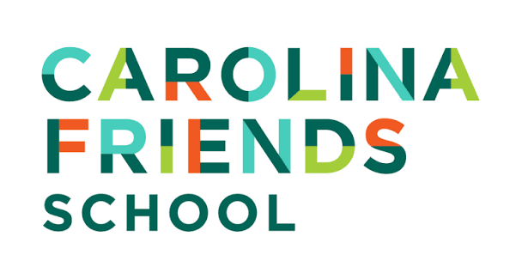
Assistant Director of Advancement
The Organization:
Carolina Friends School is a preK-12, all-gender day school inspired by Quaker values and committed to excellence in all we do. Every day, we empower our students to question the world around them, discover their passions, think deeply, and use their voices in service of the greater good.
The Opportunity:
Carolina Friends School (CFS) seeks an experienced and strategic Assistant Director of Advancement to join our Advancement Office. Reporting to the Director of Advancement, they are responsible for executing Carolina Friends School’s Annual Fund strategy and comprehensive donor stewardship program.
The successful candidate will orchestrate all Annual Fund initiatives, donor retention efforts, monthly giving programs, and stewardship events while ensuring donors receive timely, personalized, and meaningful acknowledgment and impact reporting. This position works closely with the Advancement Operations & Database Manager to transform donor data into actionable insights and ensure excellence in donor care.
Core Responsibilities
Annual Fund Strategy and Execution
- Lead all Annual Fund initiatives, including our October Giving Day, December appeals, and Spring campaign
- Develop segmented Annual Fund strategies for diverse constituent groups across the CFS community
- Partner with the Director of Advancement on leadership Annual Fund solicitations ($1,000–$25,000)
- Monitor progress toward the $500,000 Annual Fund goal and adjust strategies as needed
Donor Retention and LYBUNT (Last Year But Not This Year) Strategy
- Lead the annual LYBUNT identification and re-engagement strategy
- Segment LYBUNT donors by giving history, constituency, and engagement
- Create and coordinate multi-touch outreach plans incorporating email, mail, personal calls and notes
- Analyze retention metrics annually and recommend continuous improvements
Monthly Giving Program
- Launch, manage, and grow our monthly giving program
- Develop donor upgrade, renewal, and retention strategies
- Integrate monthly giving across Giving Day, alumni engagement, and key milestones such as graduation day

Donor Listening and Engagement
- Lead the annual Summer Donor Questionnaire activity, including its design, analysis of results, and coordination of follow-up conversations
- Ensure donor feedback informs Annual Fund messaging, stewardship practices, and cultivation strategies
Stewardship, Donor Experience, & Events
- Oversee donor stewardship strategy across all constituencies
- Partner with Advancement Operations to ensure timely acknowledgement and consistent donor care
- Collaborate with colleagues to capture and share donor-impact stories and photos
- Support the creation of annual Endowment reports
Strong candidates will demonstrate
- At least five years of experience in annual giving, stewardship, or development
- Strong project management and execution skills
- Experience working with donor databases (Raiser’s Edge or similar)
- Analytical approach to donor retention and revenue growth
- Excellent interpersonal skills and a donor-centered mindset
- An affinity for and interest in the Quaker values as embodied in the CFS community
- Commitment to understanding and exploring how power and inequality, influenced by factors such as race, class, gender, sexuality, neurodivergence, and different physical abilities, impact our students, families, and colleagues
This is a 12-month role with a hiring range of $75,000 - $85,000 based on experience. Carolina Friends School offers a comprehensive benefits package, generous holidays and vacation time, and a supportive, inclusive work environment.
Candidates from diverse cultural and ethnic backgrounds are strongly encouraged to apply.
APPLICANTS: Please review the Who We Are, Commitment to Diversity and Inclusivity, and Important Information for All Applicants sections on the CFS employment opportunities page.
Carolina Friends School actively strives to be a community of staff, students, and families of diverse backgrounds. CFS does not discriminate based on age, race, color, gender, gender identity, sexual orientation, religion, disability, socio-economic background, family structure, national or ethnic origin, genetic information, or military service in the administration of its policies and programs.
APPLY HERE
Carolina Friends School has engaged Capital Development Services (CapDev) to conduct a search for this position. Candidates are required to submit a cover letter and a resume. All materials will be kept confidential. Application materials will be reviewed as received. Additional inquiries may be directed to search@capdev.com.

