

Cape Fear Academy
Wilmington, NC
Position Announcement and Leadership Profile
Director of Advancement

A Transformational Opportunity for a Visionary Advancement Leader

Cape Fear Academy (CFA) stands at the threshold of a bold new era. With the adoption of a comprehensive master plan - a 10–12-year vision that will expand the campus footprint, create inspiring new facilities, and enable significant growth in enrollment – CFA is preparing for one of the most ambitious chapters in its history. Phase I of this plan, a $20 million investment in campus enhancements, is set to begin in June 2026, with a feasibility study concluding in late 2025 to guide this initial component of a five-phase strategy for the next decade.

For the next Director of Advancement, this moment presents an unparalleled opportunity to lead a community through a period of transformation. The successful candidate will not only shape and execute fundraising strategies that fuel the master plan, but also build lasting partnerships with parents, alumni, and the wider Wilmington community. They will be the architect of relationships and resources that ensure that CFA continues to thrive, preparing students to succeed in college and in life.

Cape Fear Academy is a learning community committed to discovering and developing individual potential, preparing each student for success in college and in life. Operating on core values of respect, integrity, accountability, and resilience, Cape Fear Academy develops leaders, ready to make a difference wherever they go. In the fall of 2025, CFA enrolled 809 students that encompass grades pre-K through 12, with an average class size of 14 and a nine-to-one student-teacher ratio. Every student is encouraged individually to reach his or her potential and to become competitive in the global environment. Since its founding in 1967, Cape Fear Academy remains firmly focused on what matters most: ability to read and think critically, analyze scientifically, speak articulately and interact ethically and effectively with one’s peers. These qualities are more important today than ever before, given our fast-paced, highly connected world.
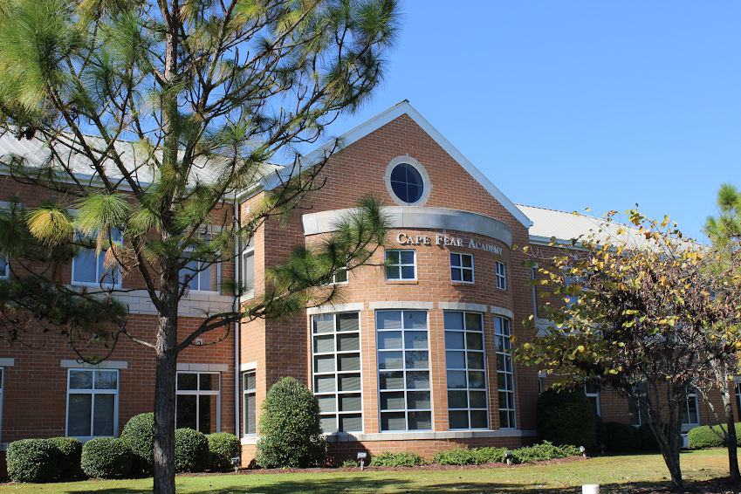
Located in Wilmington, NC, one of the South’s most vibrant coastal cities, CFA combines academic excellence, close-knit community, and a spirit of innovation with the natural beauty and cultural richness of its surroundings. Wilmington is considered one of the most beautiful cities in the south and prides itself on providing exceptional quality of life services for its citizens. In 2014, Wilmington was honored with the title of "Best Riverfront City in America" by USA Today's 10 Best reader's poll. Wilmington is home to a state port, an international airport and a regional teaching hospital (Novant/New Hanover Regional Medical Center). It is also home to the University of North Carolina Wilmington and Cape Fear Community College. As North Carolina’s most accessible coastal destination, the area’s location, natural beauty, culture and history all charm visitors and residents.


Director of Advancement| Essential Functions

The Director of Advancement is a senior management, Leadership Team position at Cape Fear Academy that is responsible for advancing the school through its development work, marketing, communications, special events and constituent relations. The Advancement Director collaborates with the Head of School and the school’s leadership team to provide strategic direction to protect and enhance the school’s image internally and externally, consistent with the mission and values of Cape Fear Academy. Specific responsibilities are:

- Establish and execute forward-thinking development/advancement and strategic programs that optimally grow the annual fund, major gifts and capital campaigns, and legacy gifts through planned giving.
- Nurture and maintain a highly collaborative relationship with the head of school, the board chair, the board’s development committee, and individual board members, supporting them in all their fundraising responsibilities, and accompanying them on donor visits when appropriate.
- Supervise the Director of Communications and coordinate the Director of Enrollment to produce fund raising and other marketing materials to expand and enhance the school’s visibility and reputation.
- Manage the development office, alumni office, special events, and communications budget.
- Oversee all internal communications (Hurricane Tracker, annual report, Academy News, Parent/Student Handbook, Directory).
- Develop and assist with external collaborations with area businesses and organizations, enhance existing relationships while building new relationships, systems, and programs that further tap into the generosity and resources of the community.
- Manage your staff to strengthen relationships with the school’s alumni and further develop alumni programming - The Family Partnership.
- Responsible for the organization and oversight of all special events.
- Serve on the Senior Leadership Team.
- Perform other duties as assigned by the Head of School.

Director of Advancement| Critical Knowledge, Skills, and Abilities

The ideal candidate will have seven or more years’ experience in non-profit, educational fundraising and five years of experience managing development, marketing, admissions or other advancement personnel. Independent school experience is preferred in the field of development/alumni relations and a demonstrated mastery of fundraising techniques and skills in all aspects of development. These should include:

- Strong knowledge of development and fundraising practices and strategies
- Proven success in directly soliciting and closing charitable gifts
- Experience working with and motivating volunteers and staff members
- Strong interpersonal skills and ability to work with all the school’s constituents while maintaining strict confidentiality
- Ability to develop and foster good relationships with a significant segment of community leaders and external media outlets
- Excellent verbal and written communication skills
- Strategic thinker with a “can-do” style
- Passionate about working with a wide range of individuals from diverse backgrounds
- Outstanding knowledge of fundraising data software and database management software
- Familiarity with the local community
- Ability to collaborate, prioritize, organize, exercise good judgment, and model Cape Fear Academy’s core values of respect, integrity, resilience and accountability
- Bachelor’s degree required

To apply, please upload your resume and cover letter using this link.

