

Director of Finance & Administration

Position Announcement

May 7, 2025

To apply, please click HERE.

Salary: $90,000 - $100,000 plus benefits

Applications requested by June 6, 2025
and accepted until the position is filled.

The Opportunity
Families Together, a nonprofit based in Raleigh, North Carolina, seeks a strategic, mission-driven, and experienced professional to serve as its next Director of Finance and Administration. This is a pivotal leadership role at a time of significant organizational growth, offering an exciting opportunity to shape the financial and operational future of a respected and expanding organization. The Director will serve as a key thought partner to the Executive Director, providing financial oversight, ensuring strong internal systems, and guiding the organization’s budgeting, forecasting, and administrative functions. In addition to managing finance and operations, the Director will play a vital role in supporting strategic decision-making, enhancing organizational effectiveness, and ensuring sustainability as Families Together responds to the increasing challenges of homelessness and housing insecurity. The Director will lead a small team, including a bookkeeper and grants accounting specialist, working collaboratively to support the organization’s mission and long-term goals.

The Organization

Established in 1980 as Pan Lutheran Ministries, today, Families Together is a diverse, community-based nonprofit and one of the largest in our community, solely dedicated to ending family homelessness. The organization’s mission is to assist families with children in transitioning from homelessness to sustainable housing and stable homes through a combination of direct support and advocacy. The organization takes a hybrid strategic approach to a growing, complex problem by employing multiple housing and service models, developing, and owning housing stock, and advocating with allied organizations to change policy and practice. Their fundamental belief is that every family deserves a home, and children should never have to wonder where they will sleep at night.




Families Together operates an emergency shelter that, in 2024, served 240 families and manages a rehousing program that assisted over 57 families in securing permanent rental housing. It also owns and operates a property portfolio that includes shelter, bridge, and permanent rental housing, and it provides ongoing support through a team of Mentor Advocates who provide case management, specialized support services, and connections to community resources. In 2024, Families Together served over 740 individuals. Of those housed through their rapid rehousing program, 98% graduated by maintaining a lease in their own name for a year.

Families Together’s core values are Care, Trust, Advocacy, and Transformation. We seek to partner with families in their transition from homelessness to home and include people with lived experience in our organizational decision-making. The Board has adopted a robust strategic plan that envisions an organizational culture where passionate team members see themselves as leaders, are committed to personal and professional growth, and seek to embody the organization’s values through their daily actions.

Families Together is led by an active and engaged Board of Directors comprised of dedicated community volunteers. The organization employs a staff of 17 full-time and five part-time employees. This team is supplemented by a cadre of over 400 volunteers. In FY25, the operating budget is approximately $2.7 million, 50% of which is through private philanthropic support. You can learn more about Families Together at their website: www.familiestogethernc.org
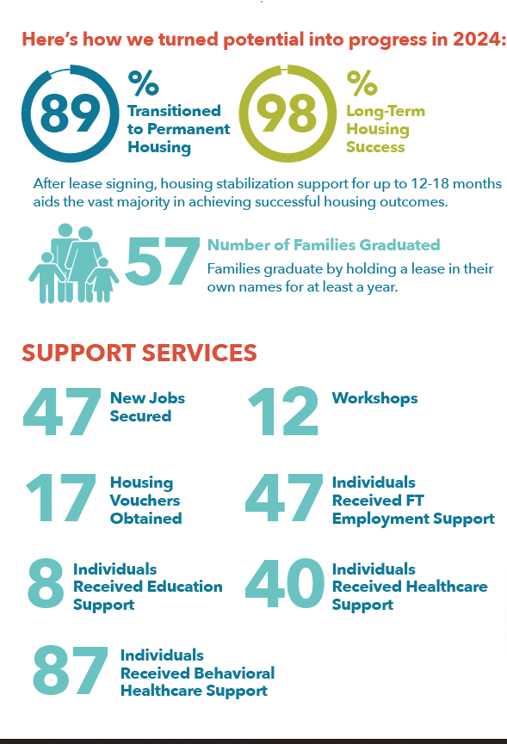
In 2024, the team achieved the results in this infographic.

The Position
The Director of Finance and Administration is a key senior leadership role at Families Together. The successful candidate will lead a team and oversee all financial, accounting, and investment activities, maintaining excellent financial transparency and working with the senior leadership team to drive the organization's strategy. They will manage the organization's financial operations, administrative functions, and human resources, ensure regulatory and financial compliance, maintain internal accounting standards, and act as primary liaison with external auditors and the Board Finance Committee. This position will work cross-departmentally on best practices, process improvements, financial standards, and will oversee all financial documentation, accounting, reporting, payroll processing, grant management, and budgets, ensuring accuracy, timeliness, and adherence to internal and external requirements. The Director of Finance and Administration will be a member of the organization's leadership team and a strategic partner to the Executive Director, contributing thought leadership to ensure long-term financial stability and sustainability. This is a hybrid workplace position with at least three days in the office per week.

The Location
The City of Raleigh is the capital of North Carolina, home to several colleges and universities, as well as abundant arts, culture, and recreational opportunities. Fueled by an impressive mix of education, ingenuity, and collaboration, Raleigh and the surrounding “Research Triangle” region routinely rank among the nation’s best places to live, work, and play. Home to more than two million people, the Research Triangle Park has attracted hundreds of companies to the region, helping to make it the largest research park in the United States. Perfectly positioned midway between the coast and the Appalachian Mountains, the Triangle offers residents a beautiful place to call home. And while the region continues to grow and offer a superior quality of life, the cost of living remains reasonable relative to comparable cities.
Core Responsibilities
The Director of Finance and Administration will work with the Executive Director, organizational leadership, and the finance team to focus on the following areas:
Financial Management and Accounting Oversight
- Identify and assess financial risks and develop strategies to mitigate them, ensuring organizational financial stability. Work collaboratively with directors and staff on daily finance and accounting activities.
- Develop, implement, manage, and document financial policies and procedures that are in accordance with best practices for nonprofit organizations.
- Oversee the general ledger, including management of any bookkeeping functions, ensuring accurate and timely financial reporting, budgeting, and analysis.
- Serve as organizational lead for annual tax preparation, external audit, and government grant single audit requirements, providing necessary documentation and supporting schedules, and ensure compliance with federal, state, and local regulations, including tax filings, grant reporting, and audits; implement recommendations from external audits to improve financial processes and internal controls.
- Oversee the fixed asset ledger, ensuring accurate recording of additions, disposals, and capital project expenditures, while maintaining compliance with depreciation policies and accounting standards.
- Train and support bookkeepers and oversee the recording of all financial transactions to ensure the accuracy and completeness of data entry, ledgers, reconciliations, and month-end activities.
- Maintain a solid understanding of the organization’s financial health and ensure financial practices align with Families Together’s mission and long-term goals.

Leadership & Collaboration
- Serve as a financial resource for leadership and staff, providing advice and insights into financial decisions.
- Build and lead the Finance and Administration department, including developing processes and procedures to support organizational growth.
- Manage and mentor a team of three direct reports: Bookkeeper, Grant Accounting Specialist, and Administrative Assistant.
- Collaborate with the Treasurer and Executive Director and report to both the Finance Committee and the HR/Legal Committee.
- Design and deliver financial training for staff to improve financial literacy and empower teams to align with budgetary goals.
- Support staff in understanding budget, compliance, and grant-related financial requirements and procedures.
- Participate in strategic planning discussions and work with other departments to ensure financial sustainability and alignment with organizational goals.
- Foster a culture of transparency, accountability, and financial literacy across the organization.
- Evaluate and recommend financial software or tools to streamline processes and improve reporting, tracking, and analysis efficiency.

Financial Planning, Analysis, & Reporting
- Lead the annual budgeting process, working with Families Together leadership to allocate resources effectively and efficiently across the organization’s programs and operations.
- Provide monthly financial statements and reports to the Executive Director, Finance Committee, and Board of Directors, including detailed analyses of revenue, expenses, and key financial trends.
- Provide the Leadership Team with monthly financial reports and analysis to assist in tracking grant spending, ensuring operational compliance, and gaining insights.
- Track the organization's financial performance against budget and provide actionable insights and recommendations for improvement.
- Assist in forecasting, preparing financial projections, and conducting scenario and ad hoc analyses for future needs of the organization.
- Conduct periodic internal reviews to ensure adherence to financial policies and compliance requirements.

Human Resources, Payroll, Benefits, and Insurance
- Oversee employee onboarding, orientation, and offboarding.
- Administer payroll, employee health insurance, and employee retirement plans to ensure financial accuracy and compliance with federal, state, and local regulations.
- Maintain employee payroll records, including new hires, terminations, pay rate changes, and benefit deductions.
- Regularly review the benefits program and insurance needs.
- Coordinate the preparation of the retirement plan Form 5500, W2s, and 1099s
- Comply with federal, state, and local legal requirements by studying existing and new legislation, anticipating future legislation, enforcing adherence to requirements, filing reports, and advising leadership and management on needed actions.
- Maintain all human resources records and assets, and ensure that records comply with best practices.
- Work with the Executive Director, senior leadership, Human Resources/Legal Committee to update the employee manual with the latest policies.

Cash Flow & Resource Management
- Monitor and manage cash flow, ensuring the organization has sufficient liquidity to meet operational and programmatic needs.
- Develop and implement strategies for maintaining financial reserves and ensuring the sustainability of Families Together programs and services.

Grant & Donor Financial Reporting
- Work with the Grant Accounting Specialist to create and maintain grant reporting and invoicing schedules to ensure compliance with grant requirements and maximize cash flow.
- Ensure that all grant financial reporting is accurate, timely, and compliant with funder requirements and tracked at the appropriate level.
- Assist the Development Team in preparing financial sections of grant applications and donor proposals; provide feedback on financial feasibility during the grant application process to ensure alignment with organizational capacity.
- Actively participate in grant planning meetings to align financial planning with programmatic goals.
- Track restricted and unrestricted funds to ensure compliance with donor intent.

Administration and Organizational Responsibilities
- Ensure the organization is adequately safeguarded by renewing annual insurance coverage to include property insurance, workers’ compensation, umbrella liability, management liability, cyber liability, and professional liability.
- Provide comprehensive support for software, hardware, mobile devices, and office equipment to ensure that all technology systems effectively meet staff needs.
- Responsibilities include diagnosing and resolving technical issues, maintaining smooth day-to-day operations, and ensuring minimal disruption to workflows.
- Collaborate closely with external IT support vendors and service providers to escalate and resolve complex issues, implement updates or upgrades, and ensure optimal performance and security across all systems.
- Ensure cross-training between bookkeeping and administrative staff.
- Attend biweekly staff meetings and weekly 1:1s with supervisor.
- Attend board meetings and committee meetings.
- Other responsibilities as designated.

Required Attributes, Skills, and Qualifications
The Families Together Director of Finance and Administration must share a passion for ending homelessness and a commitment to the mission and the diverse clients they serve. In addition, they should possess a variety of attributes, including the following:
- Bachelor’s degree in finance, accounting, business administration, or a related field; master’s degree desired.
- Minimum of five years of progressively responsible experience in bookkeeping, financial management, budgeting, and forecasting.
- Financial and leadership experience within a nonprofit setting.
- Exceptional written and verbal communication skills, with the ability to effectively engage and collaborate with individuals at all organizational levels
- Demonstrated proficiency in leading government grant management processes and reporting.
- Thorough understanding of how to interpret regulations and guidelines from various funding agencies and use the funding mechanisms required by those agencies.
- Strong working knowledge of general accounting principles.
- Experience with payroll processing and relevant laws and regulations.
- Detail-oriented with a commitment to accuracy and compliance.
- Excellent organizational skills with the ability to manage multiple tasks and deadlines.
- Demonstrated proficiency in using technology, including standard operating systems and Microsoft Office products, particularly Excel and QuickBooks, and other databases.
- Ability to work independently and on a team within a sometimes high-stress environment while maintaining policies, professional standards, and a collaborative, compassionate attitude.
- Demonstrated ability to lead and develop staff, manage performance, and foster a positive team environment.

Schedule/Location
- Full-time, salaried position
- Hours are 8:30 am - 5:00 pm Monday-Friday; occasional evenings and weekends will be required.
- Families Together Office - 908 Plainview Drive, Raleigh, NC 27610
- Shared office environment
- ADA-compliant office setting
- Regular local travel is required; must have a clean driving record and ability to drive a personal and agency vehicle for work-related activities.
- Hybrid position with a minimum of three days a week in the office

Compensation
Families Together is committed to attracting extraordinary leaders for this position through a compensation package that includes a competitive salary in the range of $90,000 - $100,000 and a generous employee benefits package that includes health benefits, paid time off, paid holidays, and a 403b retirement plan. Families Together offers a hybrid work environment, providing an improved work-life balance for employees.

To Apply: Please send a cover letter and resume by May 30, 2025, by applying HERE. Applications will be accepted until the position is filled.

Families Together
908 Plainview Drive
Raleigh, NC 27610
https://familiestogethernc.org/

